Registration form to the 8th Photodynamic Day
To be filled and sent to
photodynamic.day@acibadem.edu.tr
together with the registration money transfer receipt for participants based in Türkiye

Title (Mrs, Mr, Dr, Assist. Prof., Assoc. Prof., Prof):
Name:
Surname:
Affiliation:

Are you:
- an academician based in Türkiye?
- a student or a post-doctoral fellow based in Türkiye?
- an academician based outside Türkiye?
- a student or a post-doctoral fellow based outside Türkiye?

Paid registration fees (see table below):

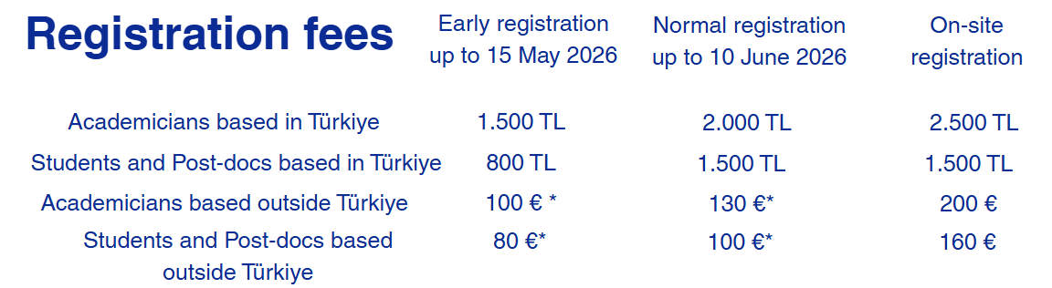

Registrations fees for participants based in Türkiye should be paid to the bank account whose details are available below.

Please kindly specify "FOTODİNAMİK + your TC number" in the “açıklama” box of the transfer procedure.
HESAP ADI: ACIBADEM MEHMET ALİ AYDINLAR ÜNİVERSİTESİ İKTİSADİ İŞLETMESİ
İSMİ: İŞBANKASI
ŞUBE: KÜÇÜKBAKKALKÖY
IBAN: TR24 0006 4000 0011 1720 7659 00
DÖVİZ: TL

Then please send the money transfer receipt together with the registration form to:
photodynamic.day@acibadem.edu.tr
​
*Registration fees for participants based outside Türkiye should be brought in cash on the day of the congress, the fees to be paid depending on the date they stated that they will participate to the congress by sending the registration form to photodynamic.day@acibadem.edu.tr

