Speakers

Patricia Forbes FRSC
University of Pretoria, South Africa (Co-Chair of PACN Congress 2026)

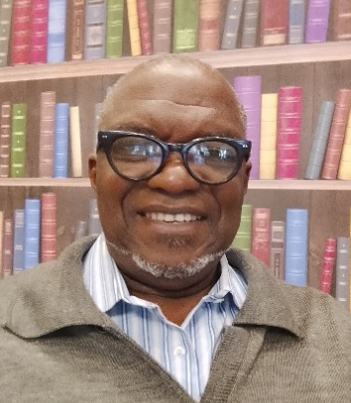
Rufus Sha’Ato
Joseph Sarwuan Tarka University, Nigeria


Christine Luscombe
Okinawa Institute of Science and Technology, Japan

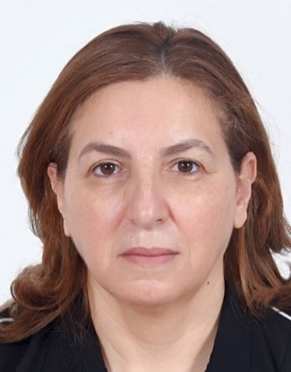
Mama El Rhazi HonFRSC
Faculty of Sciences and Technologies of Mohammedia, Morocco


Lars Ohrstrom
Chalmers University of Technology, Sweden

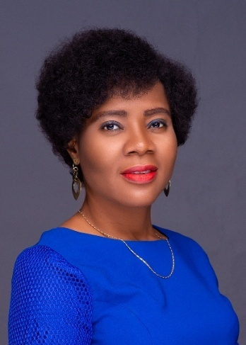
Cynthia Nkolika Ibeto FRSC
University of Nigeria Nsukka, Nigeria

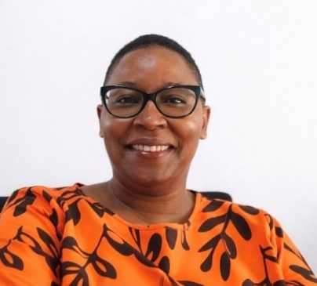
Patricia Gitari
AESA - Agriconsulting Europe SA, Kenya

Vincent Nyamori FRSC (Co-Chair of PACN Congress 2026)
University of KwaZulu-Natal, South Africa
Sir Martyn Poliakoff CBE, FRS, HonFRSC
University of Nottingham, UK
Stephen Hilton
University College London, UK
Nelson Torto
Government Chemist, Botswana & South Africa
Magda Titirici FRSC
Imperial College London, UK
Kim Jelfs FRSC
Imperial College London, UK
Solomon Derese
University of Nairobi, Kenya
Lydia Rhyman
University of Mauritius, Mauritius
Sandile Mtetwa
University of Cambridge and Rondil Scholars Hub, United Kingdom
Jane Catherine Ngila HonFRSC
African Foundation for Women & Youth in Education & STI, Kenya
Romeela Mohee FRSC
Higher Education Commissioner, Mauritius

