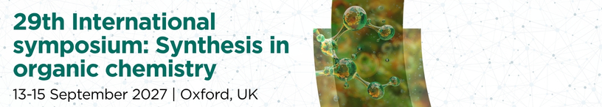

Monday 13 September 2027

11.30 | Registration (lunch from 12:30)
13:30 | Opening remarks  Jonathan Burton and Veronique Gouverneur, University of Oxford, UK
13:40 | Exhibitor flash presentations
Session 1
Session Chair:
14:00 | I01
14:45 | I02
15:30 | Refreshments
Session 2
Session Chair:
16:00 | I03
16:45 | I04
17:30 | Flash poster presentations (odd numbers)  (invited by scientific committee)
17:45 | Poster session I (odd numbers)
19:15 | Close

Tuesday 14 September 2027

Session 3
Session Chair:
09:00 | K01
10.00 | Refreshments
Session 4
Session Chair:
10:30 | I05
11.15 | I06
12:00 | Lunch
Session 5
Session Chair:
13:00 | I07
13:45 | I08
14:30 | Refreshments
Session 6
Session Chair:
15:00 | I09 (Short)
15:30 | I10 (Short)
16:00 | Flash poster presentations (even numbers)  (invited by scientific committee)
16:15 | Poster session II (even numbers)
17:45 | Close of session
18:00 | Pre-dinner drinks
18:30 | Conference dinner
Session 7
Session Chair:
20:00 | K02
21:00 | Close

Wednesday 15 September 2027

Session 8
Session Chair:
09.00 | I11
09.45 | I12
10.30 | Refreshments
Session 9
Session Chair:
11.00 | I13 (Short)
11:30 | I14 (Short)
12.00 | Lunch
Session 10
Session Chair:
13:00 | I15
13:45 | I16
14:30 | Refreshments
Session 11
Session Chair:
15:00 | I17
15:45 | I18
16:30 | Closing remarks  Jonathan Burton and Veronique Gouverneur, University of Oxford, UK

Please note that timings are subject to change.

