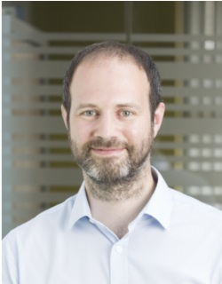
Dr Jeremy Allen, Executive Editor
Royal Society of Chemistry
View profile

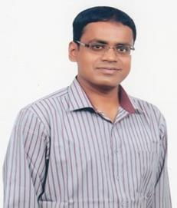
Professor Subrata Kundu, Senior Principal Scientist
CSIR-Central Electrochemical Research Institute
View profile

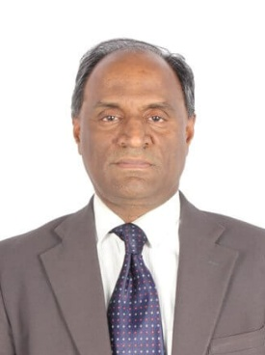
Professor Rajagopalan Vijayaraghavan, Professor Higher Academic Grade
VIT Vellore
View profile


Professor Priyankar Paira, Associate Professor
VIT Vellore
View profile


Dr Aayushi Arora, Assistant Editorial Development Manager
Royal Society of Chemistry
View profile

