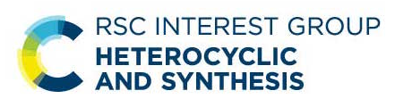

3rd Postdoctoral Symposium: Heterocyclic and Synthesis Group
Monday 18th May 2026, 11:00-16:00
To be held virtually on GoToWebinar

If you are a postdoctoral researcher interested in giving a lecture, please:
- Register your attendance via the GoToWebinar registration page (bit.ly/47Epcoo).
- Return the following form with an abstract in the template provided to the HSG Secretary (Zac Lockhart, heterocyclicgroup@gmail.com).

Presenter information:
Full name and title:
Affiliation (i.e., name of university, research institute, etc.):
E-mail address:
Name of advisor or host, if applicable:

See overleaf for abstract template.

TITLE (Calibri 12 pt bold)
Authors (Calibri 11 pt): Forename X. Surname (presenting author bold and underlined), Forename X. Surname* (name of supervisor or academic host, where appropriate, marked with an asterisk); where authors are from different institutions, please indicate so using superscript letters – ^{a,b}, etc.
Affiliation (Calibri 10 pt): ªAddress A. ^{b}Address B.
Email address of presenter (Calibri 10 pt):
Main text of abstract (Calibri 10 pt).
If possible, all diagrams should be drawn using ChemDraw ACS Document 1996 settings and centred.
References (Calibri 9 pt): See RSC formatting guidelines.

