January 2026

Luncheon for Retired Members & Guests May 8th 2026

Dear RSC Member,

You are cordially invited to a luncheon for retired members plus one guest to be held on Friday May 8th 2026 at the Randolph Hotel, Reydon, Suffolk, IP18 6PZ starting at 12.30 for 13.00. This lunch is primarily for retired members and 40-year award recipients for 2026 but other members who wish to join us may do so if there is space.

On arrival members and guests may partake of a welcome drink from the bar followed by a 3-course lunch and tea/coffee. The cost for this is just £30 each for members and one guest and is subsidised by the RSC. Additional guests will be charged £40.
If required, additional drinks etc may be paid for on an individual paid for basis from the bar.

I must submit meal choices and pay £10 deposit per head fourteen days before the event. Unfortunately it is regretted that refund of this deposit can be made only if 7 day’s notice of non-attendance is given before the event.

Please find the enclosed menu from which your choice of starter, main and dessert are to be made.

If you wish to attend please send confirmation of attendance, menu choices, and payment before 23rd April 2026. Initially please book and send menu choices to me at johnsonchemsol@gmail.com or mail to
15, Hewitts Lane, Wymondham, Norfolk, NR18 0JA. I will then send you payment details.

I look forward to seeing you on the day, where we can meet up with friends and former colleagues over an enjoyable lunch.

.

Yours Faithfully
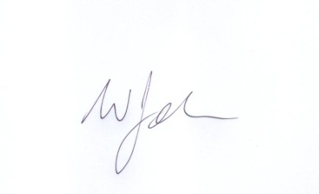
Bill Johnson

