
Professor Ian Young CBE, Chief Scientific Adviser, Food Standards Agency
Professor Young works at the FSA in a part-time capacity, whilst maintaining his current role of Consultant Chemical Pathologist at Belfast Health and Social Care Trust and Professor of Medicine at Queen’s University in Belfast, where he previously directed the Centre for Public Health.
Professor Young’s clinical and research interests relate to nutritional biomarkers and the impact of nutrition on human health, particularly cardiovascular disease. In recent years he has focussed mainly on nutritional intervention trials and epidemiological studies. He is an author of over 450 published research papers. Ian previously directed the University’s Centre for Public Health and held the post of Chief Scientific Advisor to the Department of Health in Northern Ireland and Director of Research for Health and Social Care, Northern Ireland. He also chaired the UK Government’s Scientific Advisory Committee on Nutrition from March 2020 to December 2025.
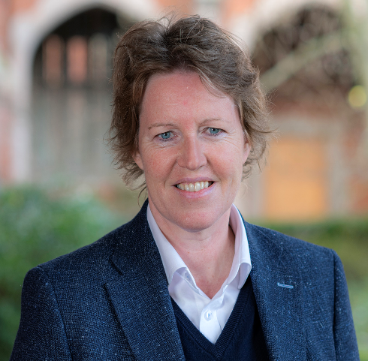
Professor Helen McCarthy, Chief Scientific and Technology Advisor for Northern Ireland, The Northern Ireland Executive
As CSTA, Helen provides scientific advice to the First Minister and Deputy First Minister, works across the executive, is an independent scientific voice, represents NI in the CSA network and advocates for science and technology across government policymaking. Helen has also recently been appointed to the Foreign Secretary and Secretary of State for Culture, Media and Sport’s UK Soft Power Council to represent Science and Technology.
Helen has been an academic at the School of Pharmacy (Queen’s University Belfast) since 2006. Helen is highly translational, having spun out her first company in 2017 to use peptides to deliver nucleic acids for mRNA vaccines. During her time as CEO (2017-23), Helen secured a portfolio of 11 Innovate UK grants as non-dilutive funding. She has spun out her second company (XapHe) in 2024 on the targeted delivery of mRNA therapeutics, a first for Northern Ireland. After securing her Chair in Nanomedicine in 2016, Helen has had numerous, cross-university leadership roles, most recently as Dean of Postgraduate Strategy (2021-2022) and Associate Pro-Vice-Chancellor for Academic Business Development (2022-2024).

Professor Dimitrios Lamprou, Chair of Biofabrication & Advanced Pharmaceutical Manufacturing and Director of Internationalisation at the School of Pharmacy, Queen’s University Belfast
Professor Dimitrios Lamprou is Chair of Biofabrication & Advanced Pharmaceutical Manufacturing and Director of Internationalisation at the School of Pharmacy, Queen’s University Belfast. He also serves as the Chair of the UK and Ireland Controlled Release Society. His research focuses on advanced drug delivery systems, pharmaceutical manufacturing, and healthcare technologies, including 3D printing, microfluidics, and personalised medicines. Working closely with industry, healthcare partners, and international collaborators, he is committed to translating research into real-world impact, supporting innovation, economic growth, and improved healthcare outcomes.

Andrew Croydon, Director of Education and Examination Policy & Partnerships, ABPI
A scientist and educationalist, Andrew started his career in Developmental Neuroscience research at King’s College London, and subsequently moved into science education, graduating with a PGCE and subsequently a Masters in Educational Leadership. After a number of years in the classroom and subsequent leadership roles within mainstream education, including Sixth Form Director and Head of a Senior School, Andrew joined the Association of the British Pharmaceutical Industry.

In his current role as Director of Education and Examination Policy & Partnerships, Andrew has focused on driving the Association’s education agenda to ensure access to a skilled workforce and inspiring STEM education – including delivery of the ABPI education initiatives covering primary school to medical school. Andrew’s recent publications in relation to careers can be found here: New research shows why Gen-Z is choosing to work in pharma (abpi.org.uk) and Gen Z are turning to TikTok for career advice and inspiration, finds new report
Alongside education and skills policy development, Andrew directs ABPI Professional Qualifications – Ofqual regulated accredited qualifications for industry personnel to meet mandatory competency. Andrew’s public speaking engagements have covered topics including: apprenticeships, STEM education, digital skills, professional examination standards and equality, diversity & inclusion – from conferences to parliamentary committee evidence sessions.



Joe Marshall, CEO, National Centre for Universities and Business (NCUB)

Formerly Chief Operating Officer and Director of Strategy at NCUB, Dr Joe Marshall took over as Chief Executive in summer 2018.

Prior to joining the National Centre, Dr Marshall has held a number of positions across government and university organisations. As an academic specialising in government education policy and practice he worked with a number of international agencies including UNESCO, WHO and the European Parliament.

A researcher at the University of Manchester, he went onto hold senior lectureship positions at Liverpool Hope University and University of Worcester before working for UK Sport (the government agency for elite sport) and then the London 2012 Olympic and Paralympic Games.

