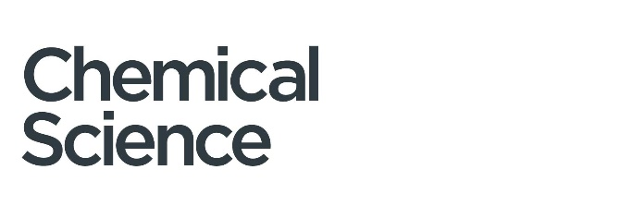


REVIEW & PERSPECTIVE PROPOSAL FORM

CHEMICAL SCIENCE

Reviews and Perspectives in Chemical Science must be authoritative, state-of-the-art accounts of the selected research field, focusing on the key developments that have shaped the topic, rather than comprehensive reviews of the literature.

The purpose of a Chemical Science Review or Perspective is to bring the reader up to date with research in a particular field, providing a critical analysis of the recent developments and assessing where further developments are imminent or of urgent need.

Reviews and Perspectives must be:
- Accessible: Of general interest, attractive and comprehensible to a broad range of chemists
- Appealing: A timely account which genuinely adds to the existing literature (rather than duplicating existing articles)
- Carefully referenced: References should be selected to give a balanced and global view of the field. We advocate for citing primary research over review articles to credit original findings. Given our broad scope across all areas of the chemical sciences, your references will likely include Chemical Science articles and papers from other leading journals.
- Carefully summarised: Summary figures rather than multiple figures from original research articles are encouraged, and full details that are available in primary work are not appropriate.
- Jargon free: Specialist terms and symbols should be defined and fundamental ideas explained so a non-specialist can understand.

Perspective articles differ from Reviews in that they are a personalised account of a research area, providing a platform for authors to give a personal or speculative viewpoint on that topic and its future developments. Authors can showcase their own contributions to the field within a Perspective, but these are not intended to be a solely personalised account of the author’s work on that topic.

Please note that Reviews and Perspective articles should not contain any original research.

PROPOSED ARTICLE TYPE: Review Perspective
PROPOSED TITLE:
AUTHOR(S):
ADDRESS:
EMAIL:
WEBPAGE (and/or Google Scholar profile):
PROPOSED SUBMISSION DATE:
SUBJECT AREAS OF RELEVANCE (mark all appropriate):

 | Analytical |  | Energy |  | Nanoscience |  | Sensors
 | Bioinorganic |  | Environmental |  | Organic materials |  | Supramolecular
 | Biomaterials |  | Inorganic |  | Organic |  | Synthetic
 | Biophysical |  | Inorganic materials |  | Physical |  | methodology
 | Catalysis |  | Main group |  | Polymers |  | Theoretical &
 | Chemical biology |  | Medicinal |  | Porous materials |  | computational
 | Other:
PROPOSAL QUESTIONS:
This is to highlight which aspect of the field you wish to review, how you are planning to cover the suggested topic and how you intend to approach it.

- Please comment on why the proposed topic is currently important

- Please explain the broad appeal and implications of this topic for the wider scientific community

- Please comment on other recent reviews published on a similar topic (minimum 3), and justify why there is room for another review

- Please provide section headings along with a brief discussion of each section and key references where appropriate. This should:
- Clearly outline the intended content of the review/perspective
- Include key studies (published in Chemical Science and beyond) used to support your review and indicate its breadth and timeliness
- A brief explanation of the personal viewpoint if a Perspective article

This proposal will be checked by the Editorial Board and team, giving them an idea of the scope of the review. This will allow them to provide initial comments on the planned review before it is written. Once a proposal is approved, please note that all submitted articles will be subject to rigorous peer-review in accordance with the journal’s quality standards and acceptance is not guaranteed.

