 | Royal Society of Chemistry  Kent Section Trust
‘An evening with Alex Wade – Conservator’
Wednesday, 7th October 2026 – arrive at 5.30pm for a 6.15pm start
Come and join us for this unique insight into the world of conservation with special reference to the newly restored Commissioner’s Hose in Chatham Historic Dockyard
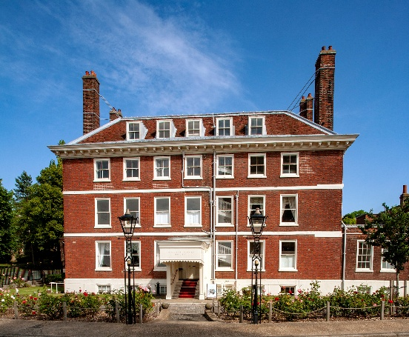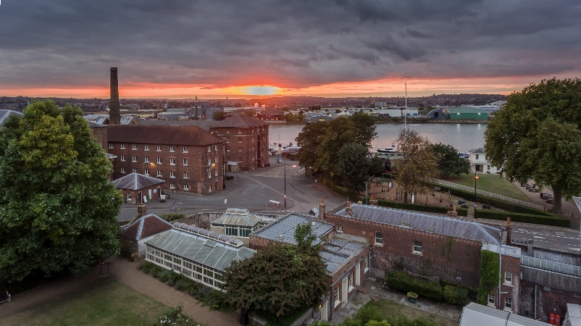
The Historic Dockyard Chatham is proud to be hosting an evening with their inhouse conservator, Alex Wade in the newly restored Commissioners House. This stunning Georgian property provides the perfect backdrop for Alex to discuss all things conservation. On arrival attendees can expect tea, coffee and an opportunity to mingle, followed by a 20-minute talk. Together, we will cover the broad basics of what heritage conservation is, and how it has developed over the years, accumulating in a discussion around the specifics of conservation science. From lab practices to research tools, analytical methods and their practical and theoretical applications. There will be an opportunity to ask questions at the end of the talk and an object and document display that will be available for self-guided discovery. This will be followed by a 45-minute tour of the house itself with our visitor experience team and the conservator who will be able to speak to the diligent work undertaken on the property
Alex is the Conservator for the Historic Dockyard Chatham, managing a large collection of mixed object collection, from books and paper to large vehicles and covering 50 scheduled and listed monuments across a conservation site. She has been active in Conservation since 2016, beginning her training in interventive conservation at Kent History and Library Centre in Maidstone. Since that time, she has worked with several large institutions covering the areas of Central London, Southern England and Wales on a wide variety of projects covering surveying, packaging, interventive treatment, exhibition production, condition analysis and much more
The event will run until around 8.00pm. Only beverages and cake are being provided with this event and the cost is £10 per person.
Places are limited so please email Sam at S.E.Booth@gre.ac.uk to book your place
Directions and meeting point instructions will be sent to attendees post-registration

