Speakers

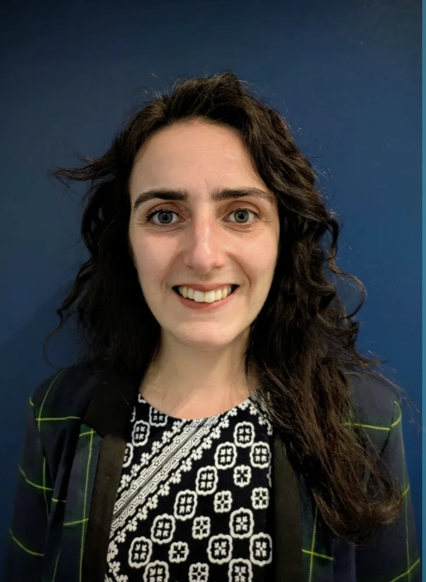
Rebecca Campbell
Executive Editor, Chemical Science
Royal Society of Chemistry
View profile

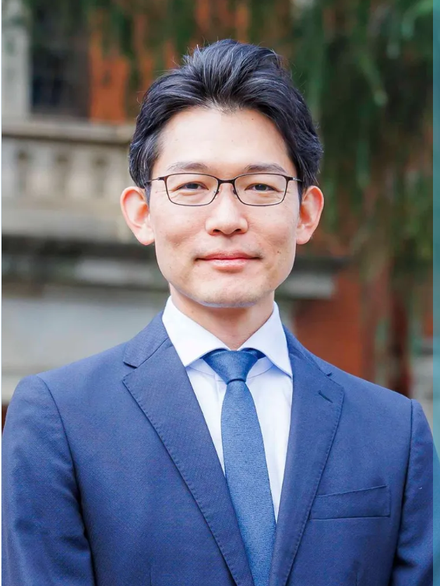
Nobuhiro Yanai
The University of Tokyo
View profile

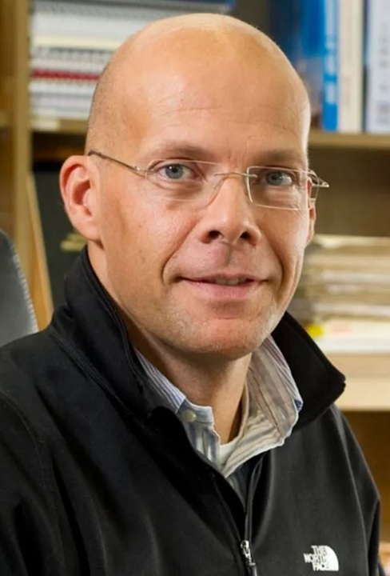
Dirk Guldi
University Erlangen-Nürnberg
View profile

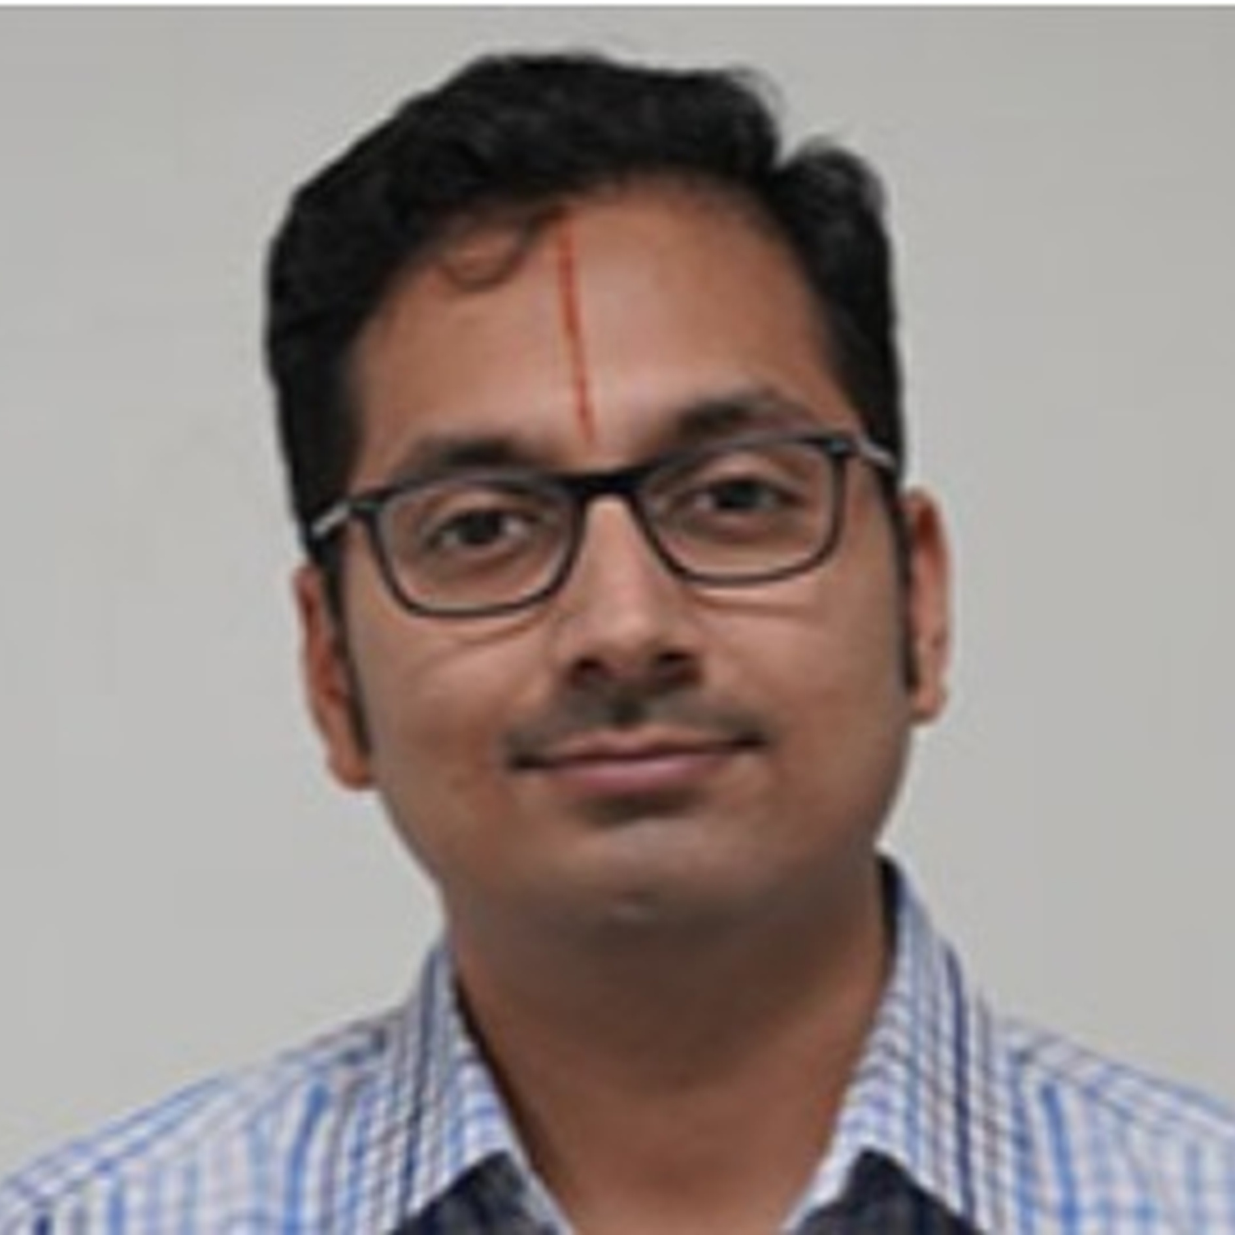
Prof. Bharathwaj Sathyamoorthy
IISER Bhopal
View profile

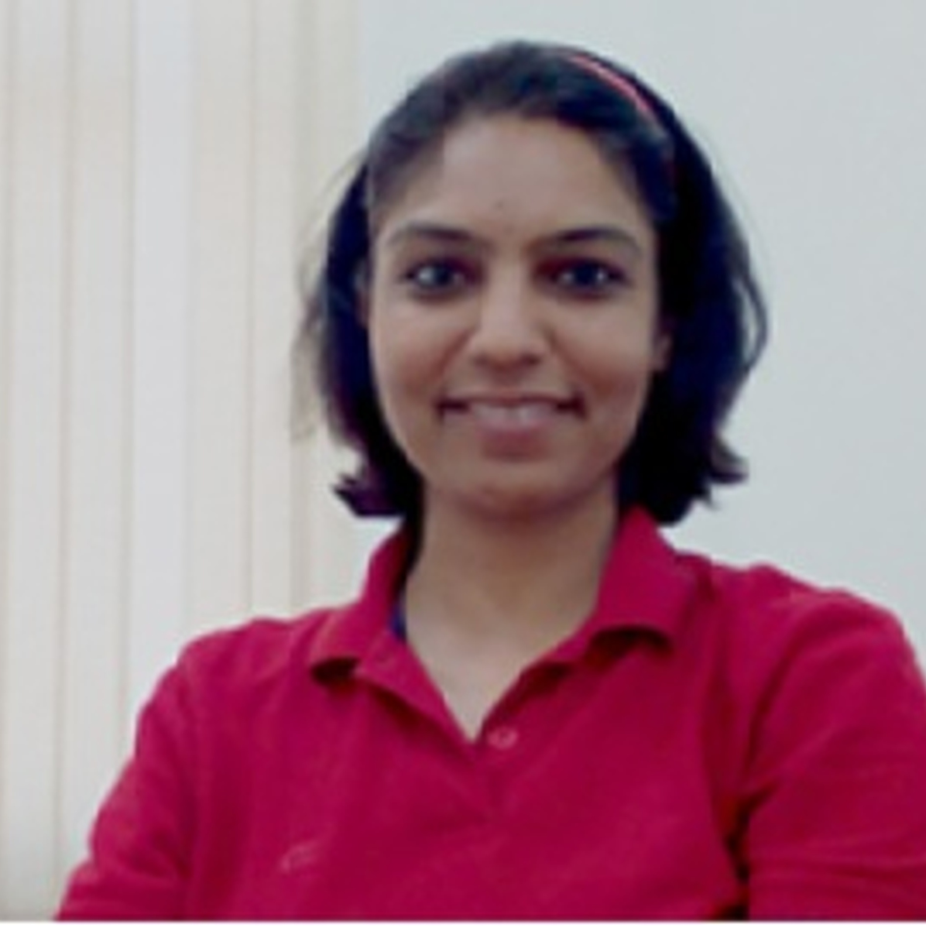
Prof. Dimpy Kalia
IISER Bhopal
View profile

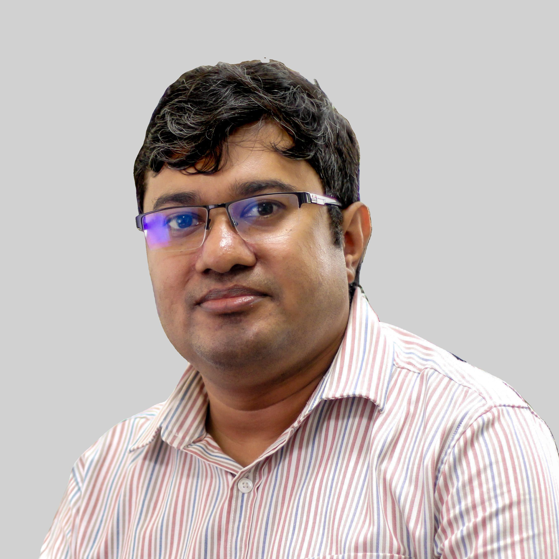
Prof. Basudev Sahoo
IISER Thiruvananthapuram
View profile

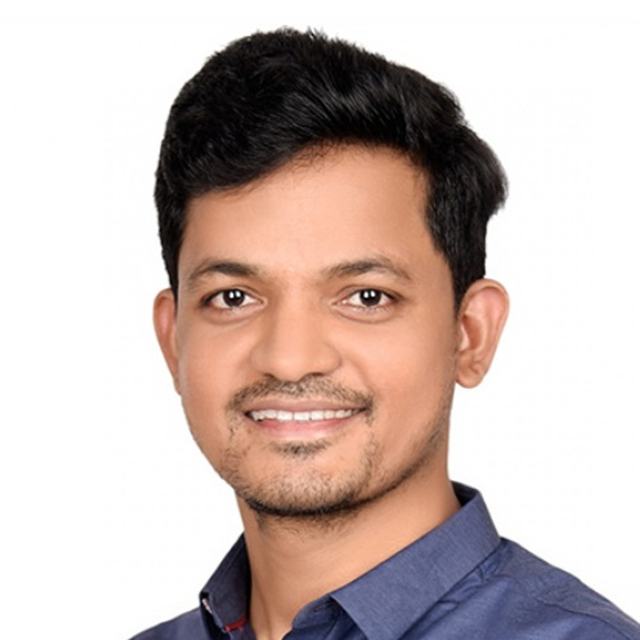
Prof. Durga Prasad Hari
IISC Bangalore
View profile

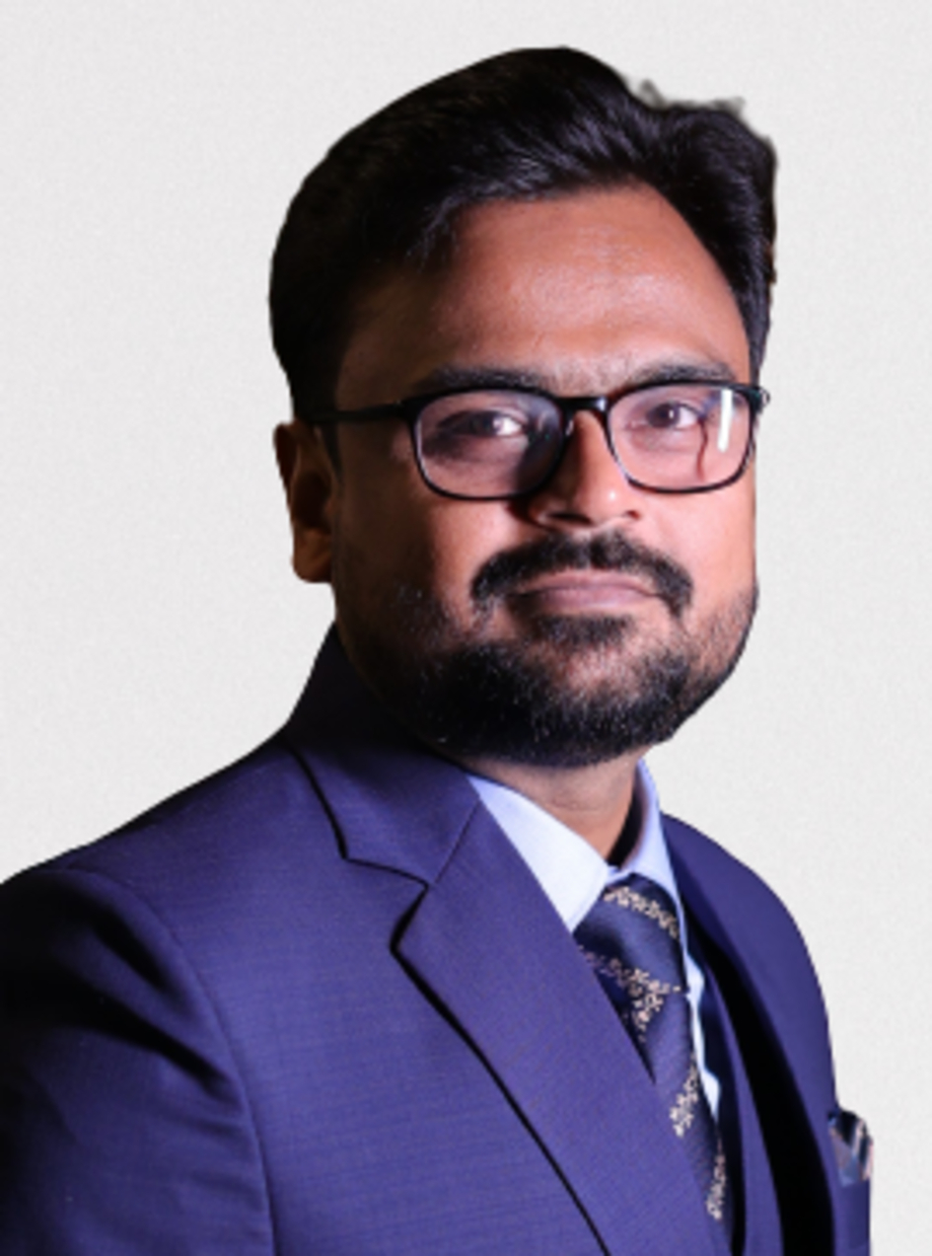
Prof. Sandip Murarka
IIT Jodhpur
View profile

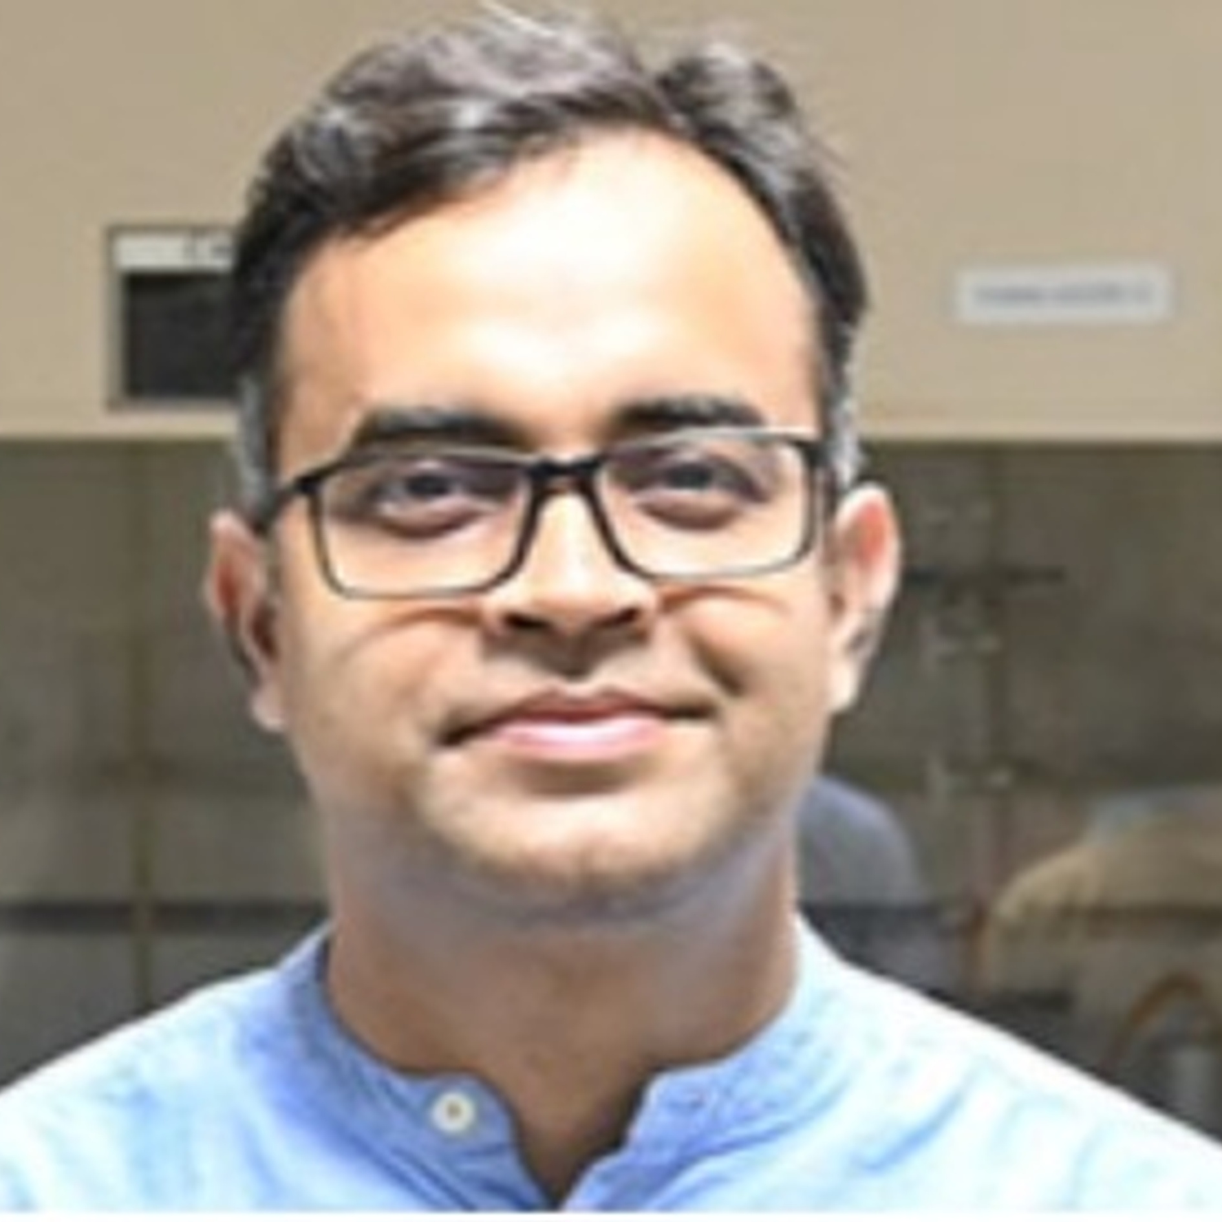
Prof. Debasish Manna
IISER Bhopal
View profile

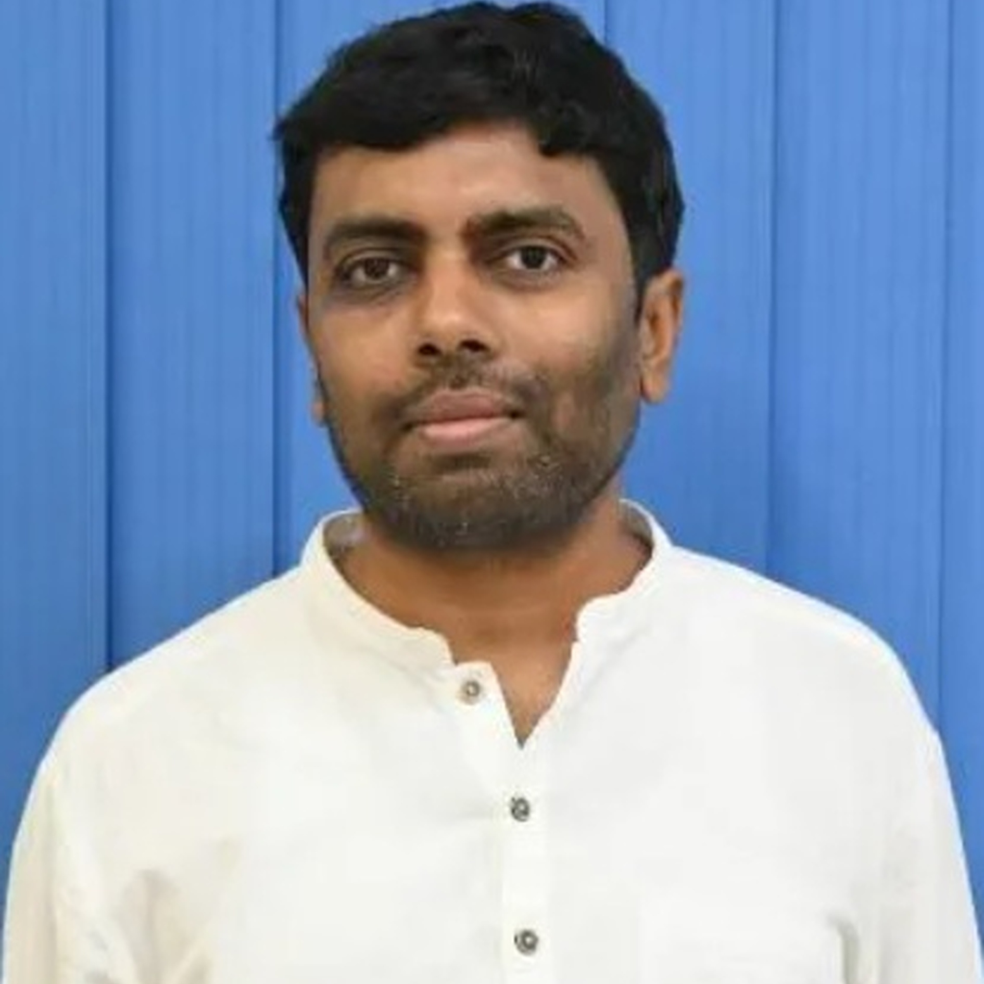
Prof. Arindam Indra
IIT BHU
View profile

