Ever Decreasing Chemistry Bob Worley FRSC, MSc
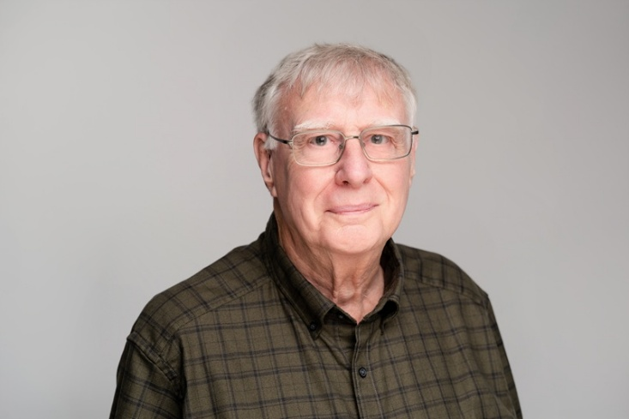

On 2nd February 1971 the carbon dioxide level in the atmosphere was 326.52 ppm. In those days laboratory equipment was both basic and hazardous. Furnaces were used to make carbon monoxide, and water gas. The demonstration of the Contact Process apparatus for making sulfur trioxide (SO₃) involved passing sulfur dioxide (SO₂) and oxygen (O₂) from cylinders over heated platinised asbestos, vented by rubber tubing leading out of the window. Most horrendous of all was reducing copper oxide (CuO) with dry hydrogen (H₂).
I was fortunate to have experienced chemists with me and a technician who could provide advice, because there was a real risk of a violent explosion from that set-up.
But I am still here!
I must thank CLEAPSS and am still able to get into the lab and solve problems in practical chemistry. My aim is to make practical work safer for teachers and students yet still ensure the beauty, enjoyment and rigour of practical work. Chemistry has a bad name within the public. Society relies on chemistry and reaps the benefits but is critical and mistreats the by-products of increased emissions and harmful waste products.
As I write this 55 years later on 2nd February 2026 the carbon dioxide level is 428.24 ppm.
(Source: https://www.co2.earth/daily-co2).
Bob Worley FRSC, MSc has spent a total of 69 years in the laboratory and 55 years
teaching chemistry and in education. In 2021 Bob won the Royal Society of Chemistry Prize for Excellence in Secondary Education. He was the 2019 winner of the RSC online poster prize competition and has co-written the book Understanding Chemistry Through Microscale Practical Work. He has spoken nationally and internationally on microscale practical work and demonstrated microscale apparatus and experiments worldwide.
After teaching for 20 years, Bob became the lead chemistry adviser at CLEAPSS. (He also finds lead (Pb) chemistry fascinating!) He revised HazCards, wrote the first handbook for preparing solutions and gases for practical lessons in schools, has delivered training to hundreds of technicians and teachers and answered thousands of questions on the CLEAPSS Helpline. He tried to retire in 2012.
He has been fortunate to meet chemistry educators from around the world who share the goal of explaining chemistry through safe, sustainable practice using easily accessible observations and measurements on a small scale.
He appeared with National Youth Theatre, has taken part in many amateur opera
productions and plays and still sings in choral concerts. He also enjoys playing bowls and bridge.
Understanding Chemistry Through Microscale Practical Work by Bob Worley & David Paterson. Association for Science Education, 2022.

